How to Sign Up for 沈老师 一年级 班级:
- Go to website: http://MLPchinese.com
- On the top right corner of any page, click Create Account, then click "Create Student Account".
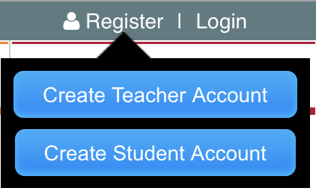
- Fill in the following information:
  - Textbook Code: (found on CD envelope or the cover of textbook)
  - Username: pick a username that the student can remember
  - Password: pick a password that the student can remember
  - Email: parent or student email (note: email will be used to reset password or recover username)
  - Chinese name: student’s Chinese name
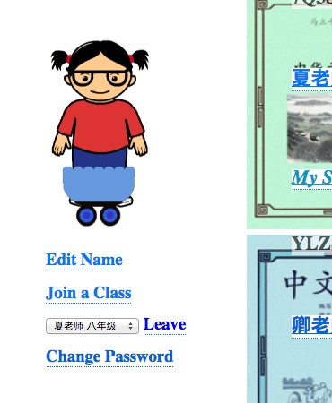
  - Classroom Code: QY9IH

If you already have an account:

Click on “Join a Class” on your account page
and put in the classroom code above

If there are any problems or bug reports, please email:
tech@mlpchinese.com
with the following info:
- username
- browser used
- screenshot of the problem
- description of the problem

